**Front-end Web Design (11056)**

**Project 2 - Responsive Website Reflection**

Tutor - Dr Ben Ennis Butler

Student – James Gardner

Student ID – u3148187

Due Date – 19/07/2019 11:59pm

Open through – Google Chrome device toolbar

The responsive website project part one consisted of researching website content and creating a concept to develop our websites around. The concept I developed is shown below;

Home page concept: Content page concept:

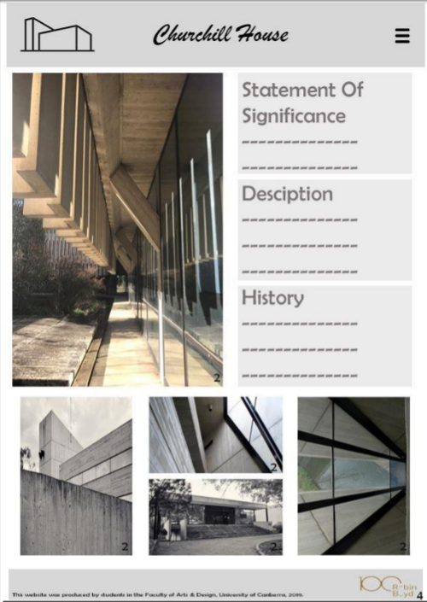 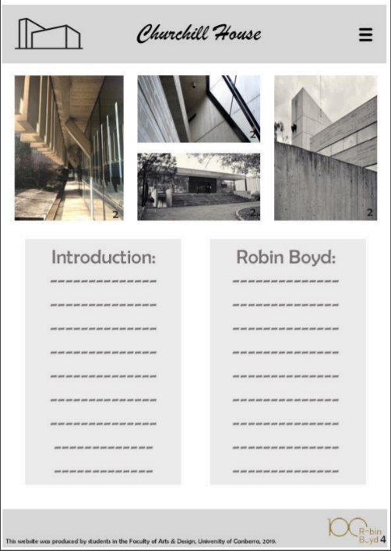

Through developing these concepts, I realised I liked the simplistic approach of the grey colour scheme to highlight features of Churchill house through the coloured images. I wanted to break the text up through providing images that related to content being shared. The homepage was to consist of small amounts of text and key images. Then further content listed with relating images.

Taking my concepts into the responsive webpage design:

The initial setup consisted of creating the working file and initially setting up the index file in html format. Creating the basic format trying to follow my concept idea closely through adding key parts of the text and key images. The html phase of the project was straight forward, I didn’t run into any major issues besides format issues with the “&” sign this was resolved through changing the input to “&amp;” as seen on the index page, line 63.

CSS pages: Firstly, construction of a reset page for the CSS was done, which allowed a fresh start for the styles CSS page I later created. Then in the CSS styles page the first steps consisted of setting font family and size constraints for the body, seen on the style’s CSS line 5, followed by creating a page wrapper seen on line 54. The next process was setting up the typography for my main content. Mainly consisting of changes for my h1, h2, h3 and main paragraphs in terms of formatting, seen in CSS line 12.

Creating the hover nav bar was challenging through the complexity of hover elements being responsive, this was approached through targeting differing areas which on prompt override the previous coding. This system is seen on the CSS page under nav hover effects line 89.

One the main elements of the index page were constructed through CSS I created the about, history and gallery pages, which all use the same formatting and similar content structure.

The most difficult component of my webpage was creating the interactive images on the homepage. These images feature a hover over link creating a boxed opacity effect. The process included going back to the index page and creating div tags to enable me to target those images, show on the index page line 40. Then in the CSS page creating image constraints, hover elements, opacity changes and implementing a link to additional pages.

Implementing the differing screen sizes for the interactive component of the sight was challenging through the complexity of pinpointing which elements were restricting the sizing. The use of the chrome inspect elements and device toolbar greatly helped this process, seen in the CSS page line 227.

Overall my responsive website uses the same initial concept colour scheme of a grey pallet and layout to a point. The difference in layout is putting images below the text opposed to beside it, this was done to prevent issues arising with scaling of the site format when being used on different devices. The images were used to break content up in my final design, because if I followed my initial concept it was very word heavy to begin with. The other change I made was to ditch the nav dropdown bar and go with an open layout to allow easier accessibility between pages.